AGGIUNGERE DEFINIZIONE AI VARI PASSAGGI DI SLICING, ROLL UP…
RIMUOVERE FILTRI CHE NON SI SA COSA FACCIANO!
This report is about Chicago Traffic Crashes (from the Chicago Data Portal). In my analysis I want’ to ask to the question about the average age of the person involved, the number and type of injuries and how this is influenced by the different conditions and type of street, for example. To this aim, I have simplified the original dataset, that contained various field not relevant for my business questions or not compiled for privacy or other motivations.
DATASETS
The first dataset is Traffic_Crashes_-_Crashes.csv that shows information about each traffic crash on city streets within the City of Chicago limits and under the jurisdiction of Chicago Police Department (CPD). About half of all crash reports, mostly minor crashes, are self-reported at the police district by the driver(s) involved and the other half are recorded at the scene by the police officer responding to the crash. Many of the crash parameters, including street condition data, weather condition, and posted speed limits, are recorded by the reporting officer based on best available information at the time, but many of these may disagree with posted information or other assessments on road conditions. If any new or updated information on a crash is received, the reporting officer may amend the crash report at a later time. A traffic crash within the city limits for which CPD is not the responding police agency, typically crashes on interstate highways, freeway ramps, and on local roads along the City boundary, are excluded from this dataset.
The original dataset contained 510.000 rows and 49 columns, but I’ve deleted some field for example the Chicago Police Department report number that for privacy is blank in some crashes or other field not useful for my purpose.
I’ve have used this first dataset to analyse the condition of the street of the crash and to give a summary visualization of the number of crushes in the different Department of Chicago (in the first dashboard) field that I’ve selected are 14 and are:
Field Name | Description | Type
CRASH_RECORD_ID | This number serves as a unique ID in this dataset | STRING
CRASH_DATE | Date and time of crash as entered by the reporting officer | DATE
DEVICE_CONDITION | Condition of traffic control device ( es. no controls, functioning properly) | STRING
WEATHER_CONDITION | Weather condition at time of crash | STRING
TRAFFICWAY_TYPE | Type of road (es. one-way, not divided) | STRING
ALIGNMENT | Street alignment at crash location (es. curve, straight) | STRING
ROADWAY_SURFACE_COND | Condition of the street(es. wet, dry) | STRING
ROAD_DEFECT | Defect of the street | STRING
PRIMARY_CONTRIBUTORY_CAUSE | The cause of the crashes | STRING
STREET_NAME | Name of the street of the crashes | STRING
BEAT_OF_OCCURENCE | Chicago Police Department Beat ID. | NUMBER
NUM_UNITS | Number of vehicle involved | NUMBER
LATITUDE | Latitude of crashes | NUMBER
LONGITUDE | Longitude of crashes | NUMBER

I’ve also selected the date from 2017 to 2020, because 2021 is still underway and it would not allow me to have a fair analysis of the accident situation in relation to other years.
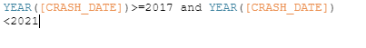
The second dataset is geo_export_ff119ed6-d009-447e-a3ff-351d7ff33e32.shp a geospatial dataset that contain the boundaries of each Police Department and the relative Beat ID, so that I can use this information to join with the previous dataset and have a visualization of the different crashes for different Department.
The third dataset is Traffic_Crashes_-_People.csv that contains information about people involved in a crash and if any injuries were sustained. Each record corresponds to an occupant in a vehicle listed in the Crash dataset. Some people involved in a crash may not have been an occupant in a motor vehicle, but may have been a pedestrian or bicyclist… A vehicle can have multiple occupants and hence have a one to many relationship between Vehicle and Person dataset. However, a pedestrian is a “unit” by itself and have a one to one relationship between the Vehicle and Person table.

I’ve used this dataset to see the conditions of the involved persons before a crashes, the results of a crashes and the safety measure adopted. To this aim the original dataset (that contained 30 fields and 1.13M rows) has been simplified to 9 fields :
Field Name | Description | Type
PERSON_ID | Serves as a unique ID for the person in this dataset | STRING
PERSON_TYPE | Type of roadway user involved in crash (es. driver, bicycle) | STRING
CRASH_RECORD_ID | The id of the crash useful to do a join | STRING
SEX | Sex of the involved person | STRING
AGE | Age of the involved person | NUMBER
SAFETY_EQUIPMENT | Safety equipment used by vehicle occupant in crash, if any | STRING
EJECTION | Whether vehicle occupant was ejected or extricated from the vehicle as a result of crash | STRING
INJURY_CLASSIFICATION | Classification of injury (es. fatal, not evident) | STRING
PHYSICAL_CONDITION | Driver’s apparent physical condition at time of crash, as observed by the reporting officer | STRING

ETL
My ETL phase consist in filtering, compute new field, grouping, aggregate and join. I’ve done this phase with Tableau Prep.
PERSON DATASET
Filtering
I’ve managed the NULL values in the major number of cases by excluding that from the dataset, and also for the rows with the name Unknow and Other, that I’ve treated as null values, so I’ve excluded them. But in the dataset “Person” there are 2 value that can be Null or Unknow, this value are Ejection and Physical condition that for person that aren’t in motor vehicle or that are pedestrian can be omitted.

Computed Field
I’ve recomputed the field EJECTION on the base of the present field EJECTION in a way that if the person is a byciclist or or a passenger the null value can be ammitted and I’ve substituted it with a NONE value, to distinguish them for the null values of the drivers, that I’ve interpretated as an unknow values and for this reason I’ve excluded them.
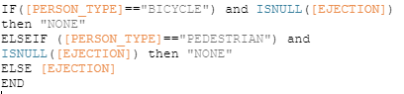

Grouping
I’ve grouped the value of the field SAFETY_EQUIPMENT In only 4 values, so that I can easier analyse if the safety equipment is used or not. I’ve groped also the value of INJURY_CLASSIFICATION in 4 categories: FATAL,INCAPACITATING,NON INCAPACITATING and NOT EVIDENT. And also for PHYSICAL_CONDITION in which have collected the values of the type alcohol/drugs in a unique value.

CRUSHES DATASET
Filtering
I’ve managed all the NULL values and the values OTHER, UNKNOW by excluding that from the dataset.

Computed Field
I’ve computed three field about the Date, that are:
SEASON
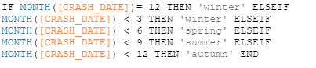
DAY PART
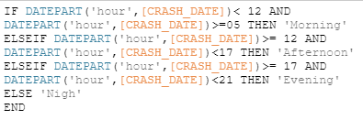

DAY TYPE
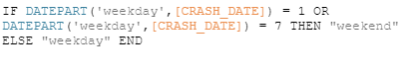
Grouping
I’ve grouped the value of the field WEATHER CONDITION so that we have to distinguish only from blowing, clear, cloudy, rain, snow climatic conditions. DEVICE CONDITION in functioning improperly, properly, no controls, not functioning. And other grouping in TRAFFICWAY TYPE, ALIGNMENT (in curve, straight), ROAD DEFECT, ROAD SURFACE CONDITION, PRIMARY CONTRIBUTORY CAUSE….
GEOSPATIAL DATASET
I’ve only changed the type of the field beat_num from string to number so that I can perform a join with the field, because the string type start with 0 and the integer not, so I’ve uniformed selected the type number to perform the join. But later I’ve reused the string type to indicate the boudnaries.

AGGREGATE DATASET
The first aggregate dataset was in the original Person dataset in which I’ve computed an aggregated field INVOLVED on the bases of the unique crash id, and I’ve count the number of occurrence of each crash id, this number represent the number of people involved in the crash identified by that id.
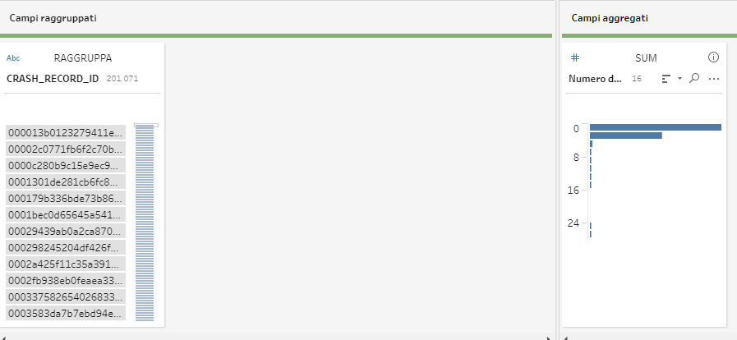

The second aggregate was on the dataset resulting from the third join, in which I’ve grouped for street name, crashes id to avoid the problem to count more defect for a street for a same crushes if in this crushes there are more people, and road defect in which I’ve considered only the negative occurrences (debris on roadway, rut, holes, worn surface) and to do this I’ve perform a filtering on this field
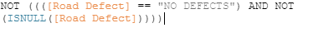
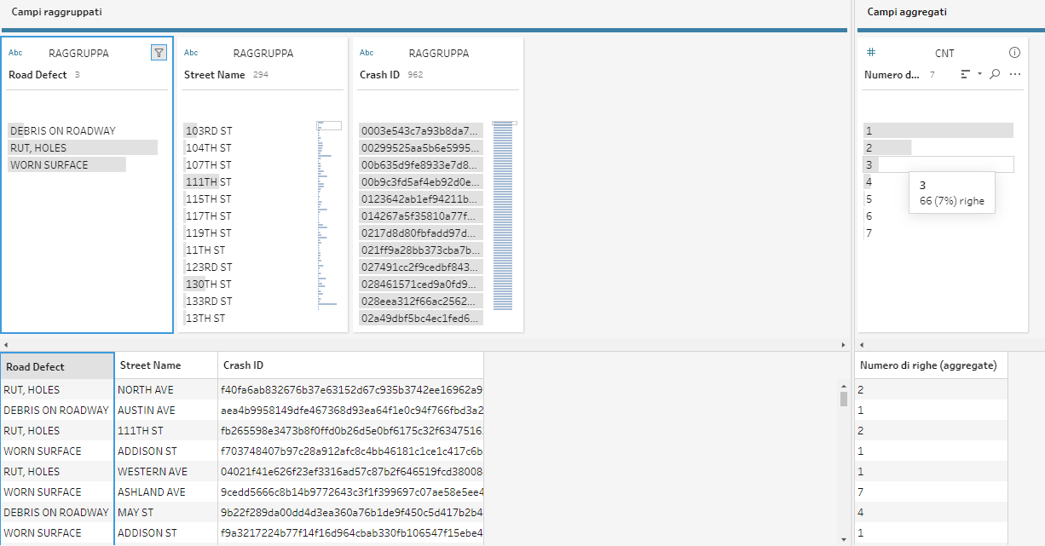
JOIN
DATASET AGGREGATE FIELD INVOLVED – PERSON DATASET :
The first join was between the dataset resulting from the aggregate operations that contains only the Crash ID and the Number of person involved and the original Person Dataset with an Inner Join in order to retain only the rows that match. Then I’ve removed the only field that was in each of the two original dataset, that is Crash_record, that in the resulting join dataset appear two times.

Join9 – Traffic Crashes DATASET :
The second join was between the dataset resulting from the first join that contain the information of each person involved in a crashes and the dataset that contains information about that crashes. Because is possible that there are crashes in which no person is registered or person involved in crashes not in the period 2017-2020. Also in this case I’ve removed the field Crash_record, that in the resulting join dataset appear two times.
Join 10-Geospatial dataset :
The third join was between the dataset resulting from the second join and the dataset that contain the geospatial coordinates of each police departments, and I’ve computed this join with an inner join of the field BEAT_OF_OCCURENCES and beat_num of the two dataset
Join 11 – Datast aggregate field Occurrences defect :
The last join was between the dataset resulting from the aggregate operations that contains Crash ID , typology of defect, street name and number of defect and the dataset resulting from the third join with an Left Join in favour of the dataset resulting from the third join based on the clausule of Crash ID, because in the dataset aggregate we take in count only the crushes occurred in street with defect, but in the final dataset I want also crashes occurred in street with no defects . Also in this case then I’ve removed the duplicates and substituted the value null present in the field occurrence defects after the join with a numeric value 0.
FINAL DATASET
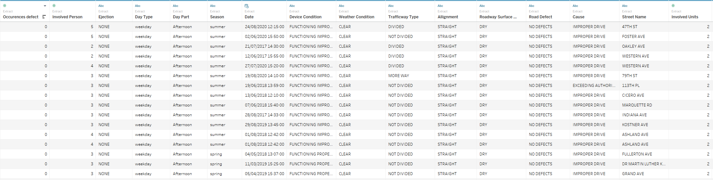

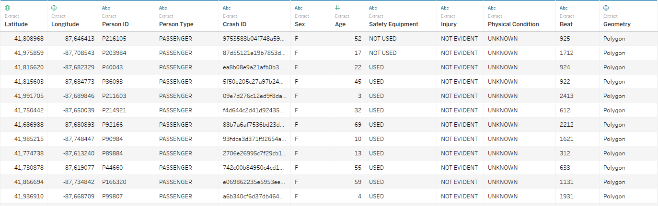
DIMENSIONAL FACT MODEL

The Dimensional Fact Model (DFM), proposed by Golfarelli & Rizzi is a graphical conceptual model that effectively supports the conceptual design of a data mart and creates an environment in which queries may be formulated intuitively. The conceptual representation generated by the DFM consists of facts, measures, dimensions, and hierarchies. I identified Crushes as the focus of interest of my analysis and Number of crashes (a field computed on Tableau) , number of person involved in each crashes, number of vehicle involved in each as the measures.
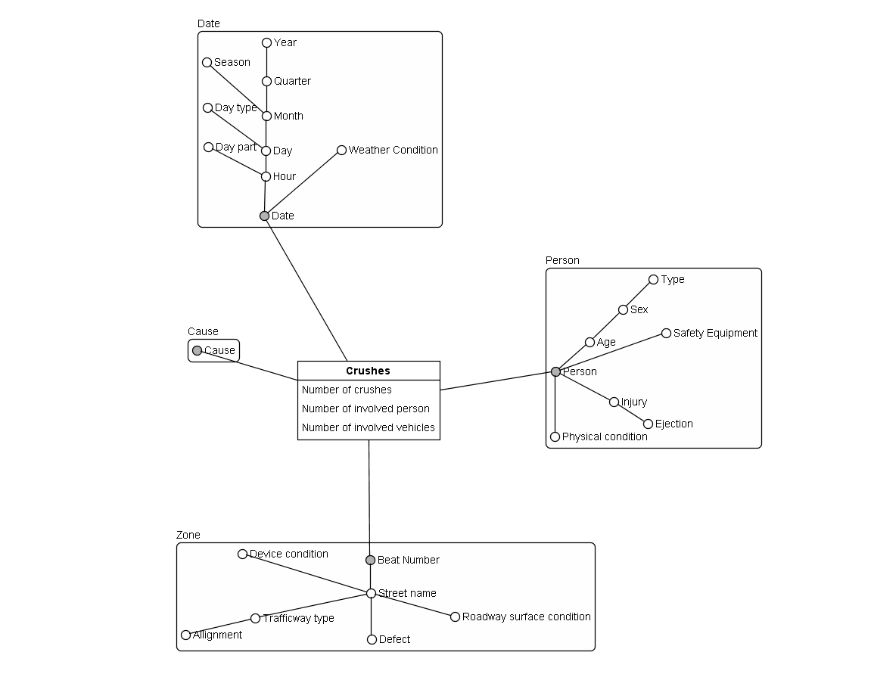
I’ve done the visualization of the DFM with Business Intelligence Modeler. These are the hierarchies of the model:
Date->Hour->Day->Month->Quarter->Year
Date->Wheather Condition
Date->Hour->Day part
Date->Hour->Day->Day type
Date->Hour->Day->Month->Season
Person->Age->Sex->Type
Person->Safety Equipment
Person->Injury->Ejection
Person->Physical condition
Beat Number->Street name->Defect
Beat Number->Street name->Trafficway type->Allignment
Beat number->Street name->Device condition
Beat number->Street name->Roadway surface condition

In tableau I’ve computed a calculated numerical field that is the measure of my DFM, Numebr of Crushes as by using an aggregate function countd, to count the number of distinct crushes id, related to a single crush.
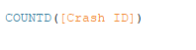
Dashboard
In order to answer the proposed business questions I’ve built two dashboards in the first dashboard I analyze
the number of crushes per area of Chicago, paying attention on the composition and condition of the street, but also the number of crushes related to different year, different Season and Day Type and the related most common number of units involve.
In this dashboard every sheet can be used as a filter and a big space is taken by the maps, in which we can see the separation of each police department, the related number of crushes and the position of the crash in the map.
It contains the following sheets:Date, Day, MAP, Street with more crushes, Street with ore occurrences, Season, Max Beat, Cause-TrafficWay,. Num units, Cake Wwather, Surface, Device Conditions.

The second dashboard shows the informations about the person involved in the crushes, paying attention to the average age, the relation between the use of safety equipment (and also ejection or cause of crash) and the typology of injury. Contains also the number of the typology of injury and all can be analysed in relation to the filter Sex, Person Type and Date that are all slider bar.

It contains the following sheets: Avg Age, Cause injury, Person Type- Injury, physical condition, Safety Equipment, Involved Persons, Numbers.

The principal color of the dashboard is the red, because is related to a message of danger. In addition I’ve used only two different typologies of black and the white for the text. So that I can have a neat and clear dashboard.

SHEETS

I’ve used 3 sheet with a similar composition and choice of graphics, because these three sheets are about the analysis of the number of crushes according to different aggregation of the sane dimension (Date).
The Date sheet show the different number of crushes per year. So I’ve put in the columns the lower level of detail of the Date, that is ANNO(Date) and in the rows the relative number of crushes. I’ve used an instogram that immediately shows the differences of crushes between the year and I’ve removed the axes of number of crashes to a more simple visualization, we can visualize the number of crushes thanks to the label over each bin that indicate the total number of crashes for that year. I’ve also added two reference line so that we can see the average number of crashes in these 4 years and the total number of crashes.
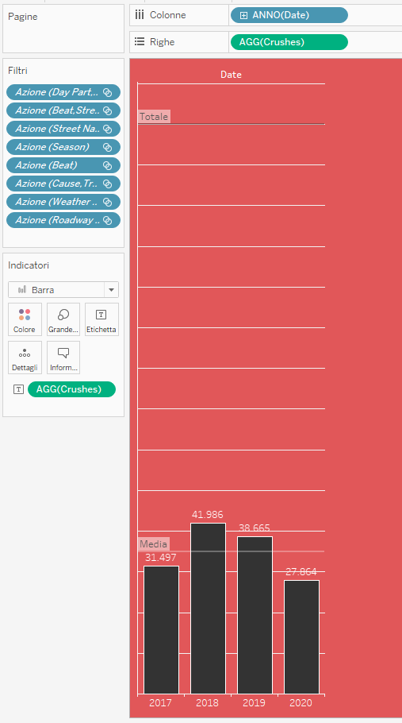

The day sheet is similar to the previous sheet but with de dirrerence that I’ve shown by doing a Drill-Down an higher level of detail with Day part (afternoon, evening, morning, night) for the two different day type (weekend, week day).

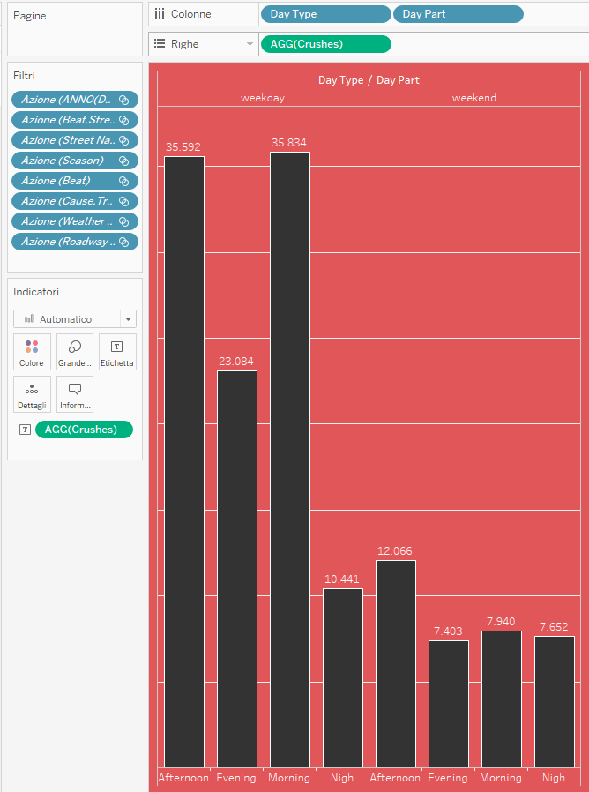

Finally Season
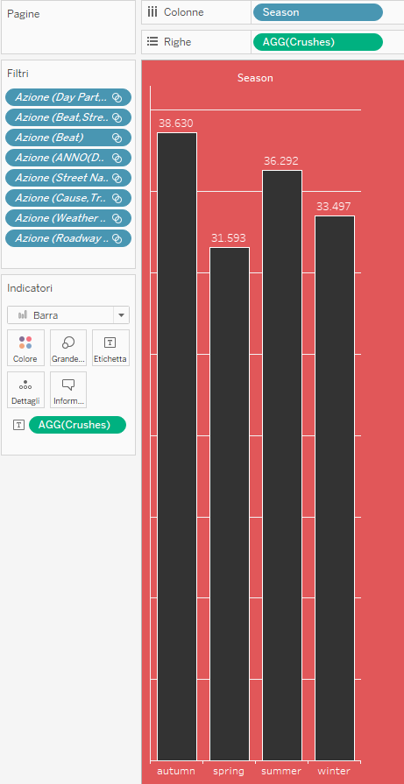

For the sheet map I’ve used the geospatial field and I’ve used the functionality of tableau to show also the street of that map, because I was interested not only to the beat number of each department id of Chicago but also on the position of the street, so a clear visualization of the street of Chicago is helpful. I’ve used for the different geospatial boundaries of the district the same of colour, with an opacity of the 5% because I’m not only interested in the number of crushes per beat (that I’ve inserted in details) but also on the position of the crashes, so is important to see also the map behind. The colour for the beat is again red, to indicate danger in that zones and also to specify to what zone the dataset is referred. On this level , I’ve added another level of indicator, but with the longitude and latitude of each street and also the name of the street.

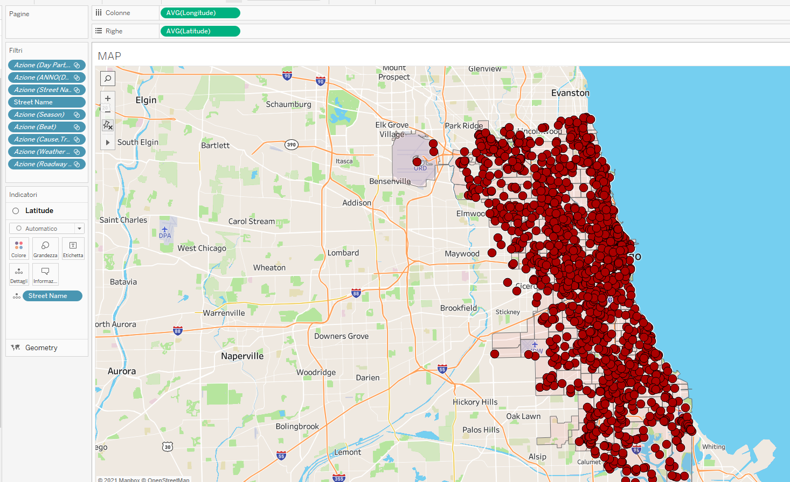

In the sheet Street with more crushes is an information in a text form that display the name of the street with more occurrences of crushes. To retrieve this information a calculated field was created, which associates to the maximum number of crushes for street.

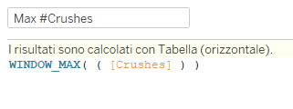

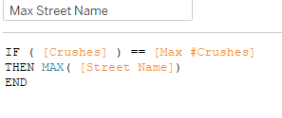
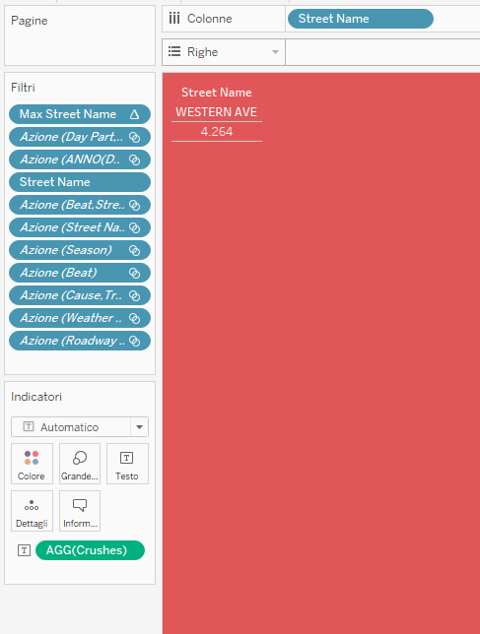
The same is done for street with more occurrences, that indicate the name of the street with more occurrences of defect that have caused a crash reported by the agent:
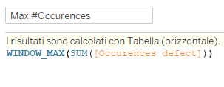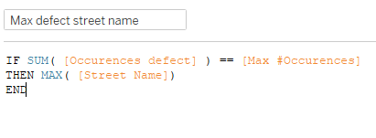
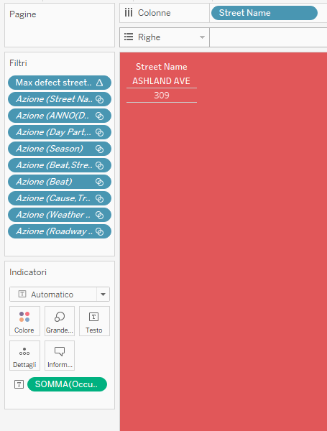
And also for Max Beat that indicate the beat with the higher number of crashes.
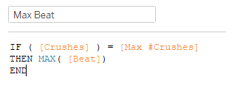
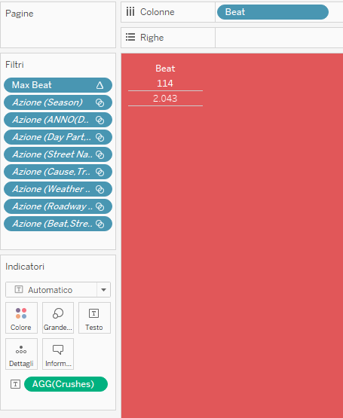
In Case-Trafficway I’ve put in the column the number of crashes in percentage and in the rows the different cause but also I’ve put the trafficway type as a color indicator, because I’m interested to know how the combination between trafficway type and cause influenced the number of crusehs.
For the color of the indicator I’ve chose a scale of red.
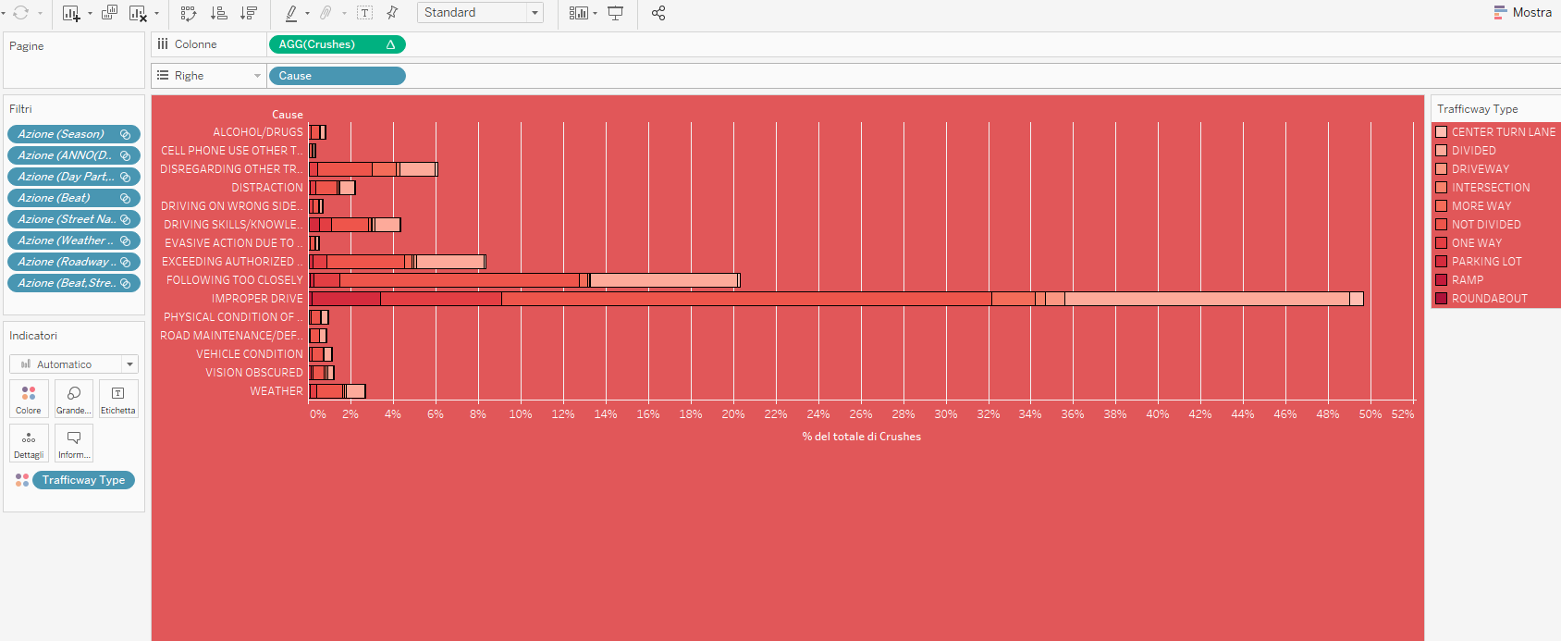

In the sheet Num units I’ve used an graphic that show the area in correspondence of the number of units involved in a crashes, to see what is the more common number of units involved in a crash.

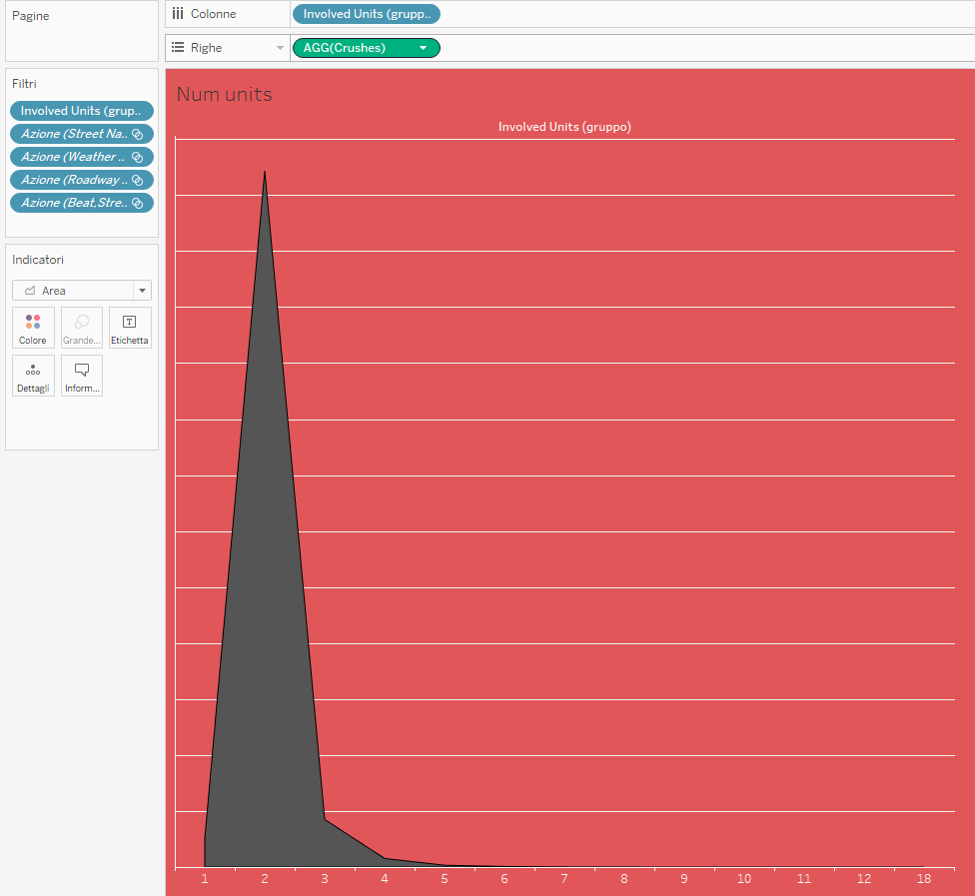
I’ve done the same for device condition to see what is the most common situation of device condition in as crush
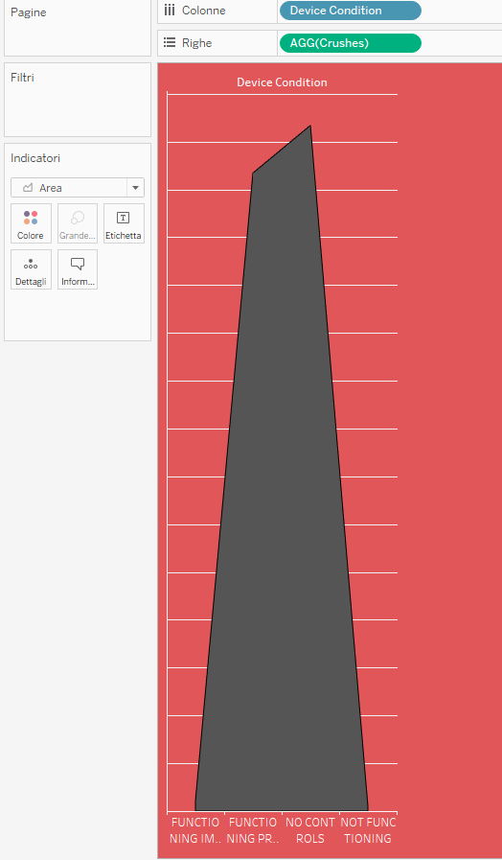
For the first dashboard I’ve finally two pie charts that show respectively the weather condition in correspondence of more crashes and the surface condition in correspondence of more crushes. Also for these two piechars I’ve put the number of chart as the entity of the angle and the dimension in the color indicator:
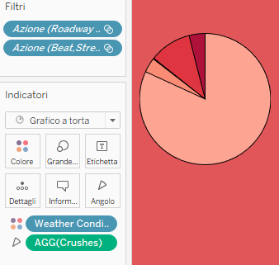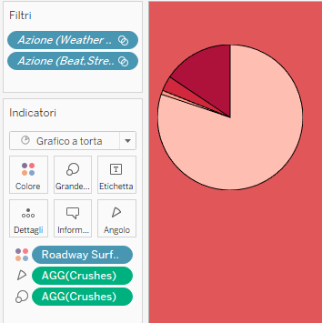

For the second Dashboard we have Avg Age that is a text label with the indication of average age of the people involved in accidents in Chicago per year, person Type and sex. I’ve used a different color background that match with the use of colour of the othere graphs, indeed I’ve used the scale of black of the bin of the instogram for example.

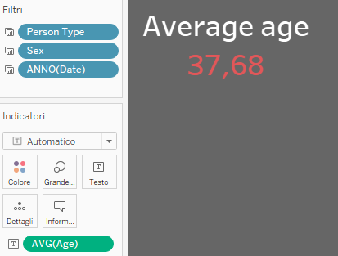

The shet Cause-Injury is a treemap that express the most common cause of accident per tipology of injury. Color intensity, as well as size are used as preattentive attributes.

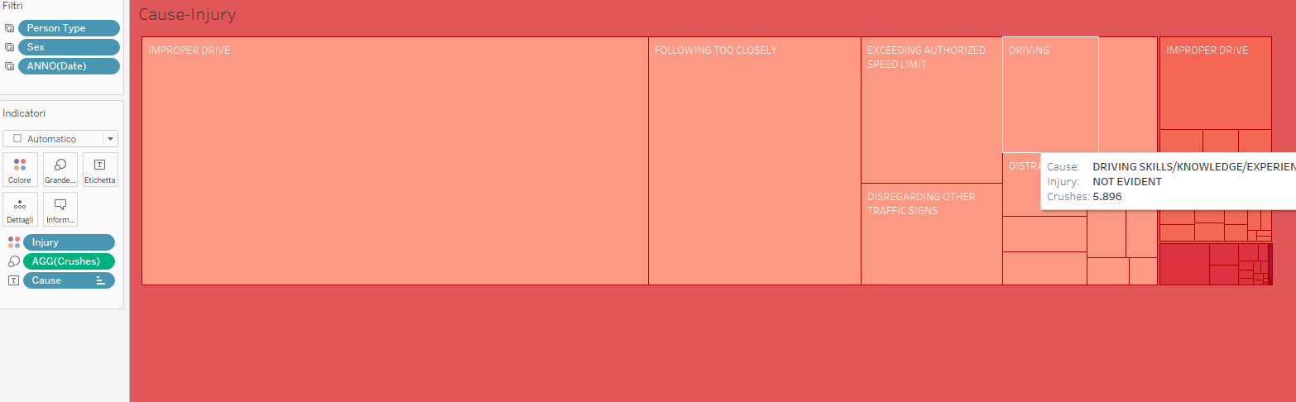
There are two sheet with the same structure: a bar-plot with a percentage of row that in the first case express the percentage of each typology of injury per the final situation of ejection and in the second case the typology of injury per the presence or not of the safety equipment. I’ve added a computed field that is Person that count the number of Person involved. I’ve selected this typology of visualization because in the case of ejection and safety equipment there is a relevant difference in the number of occurrence between the values, so is more interesting to see how the state of ejection or the state of safety equipment influenced the type of injury, rather then the number of person involved related to the value of ejection or safety equipment.
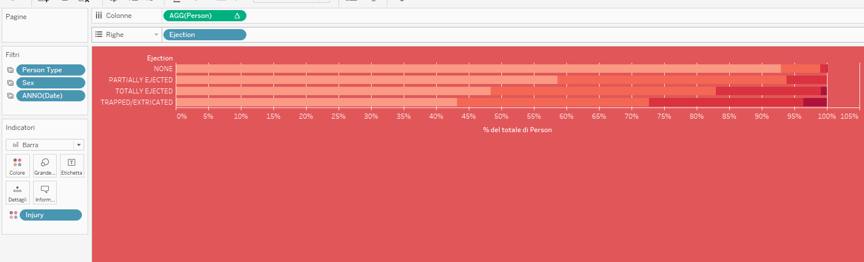

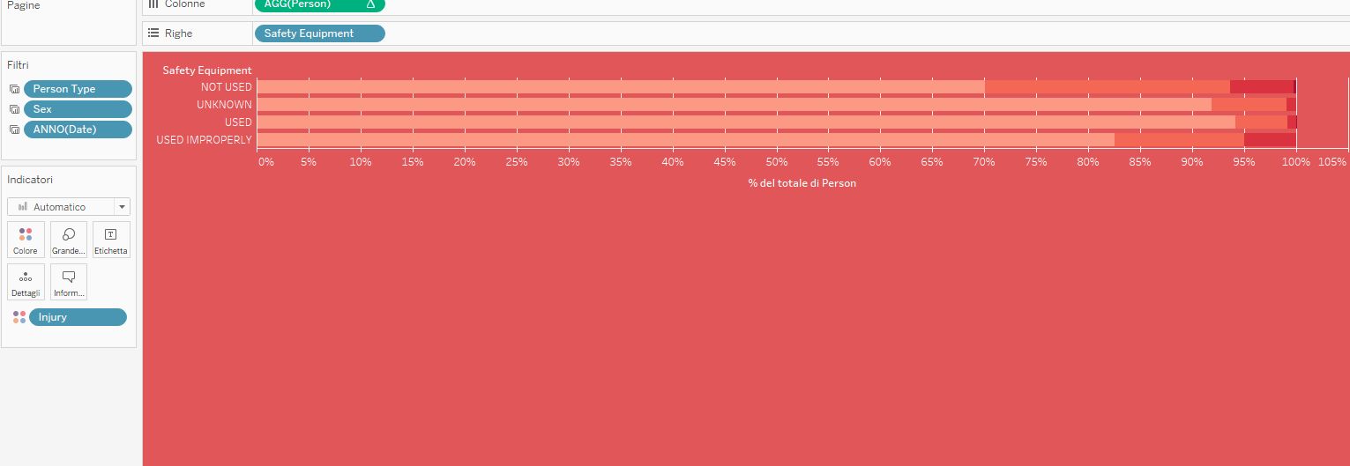

In the sheet Physical condition and Involved Persons I’ve used a plot that show the area in correspondence of the number of physical condition registered for a person involved in a crashes, to see what is the more common physical condition. And for the second plot in correspondence of the occurrence of number of person involved in a crash, to see what is the more common value for the number of person involved in a crash.
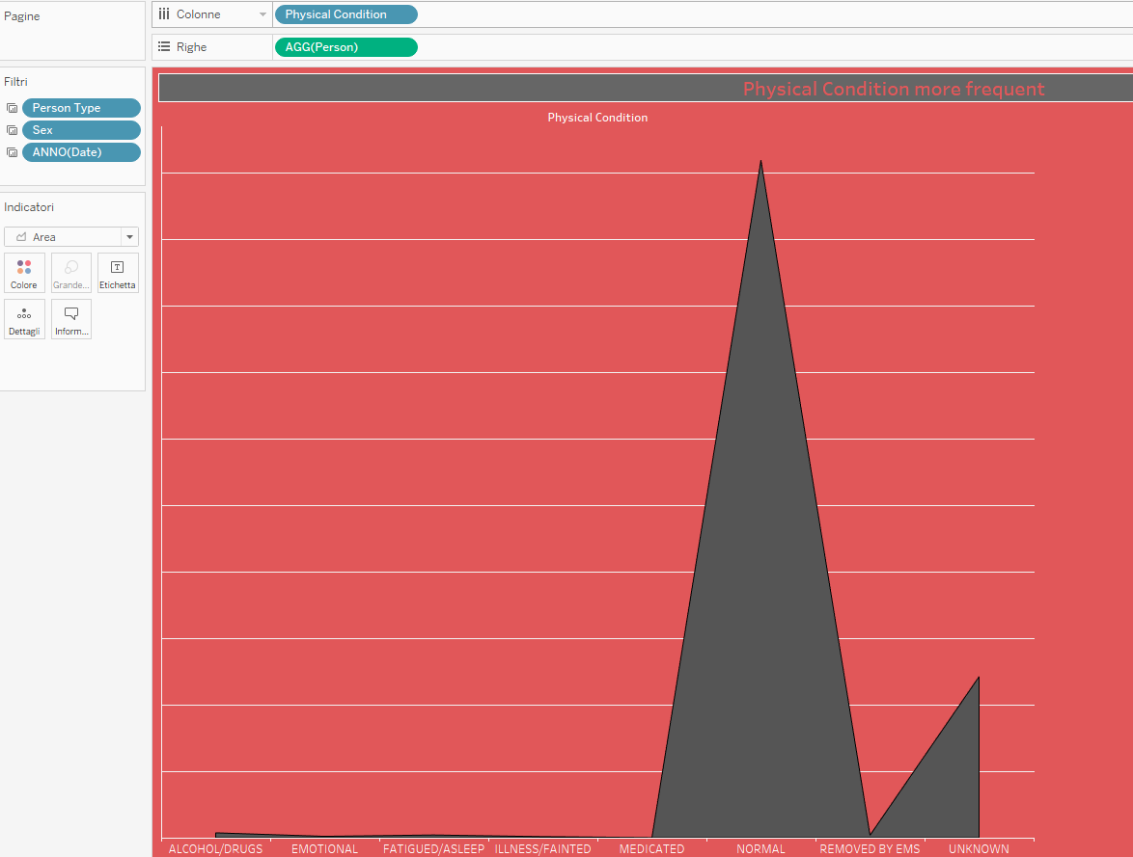
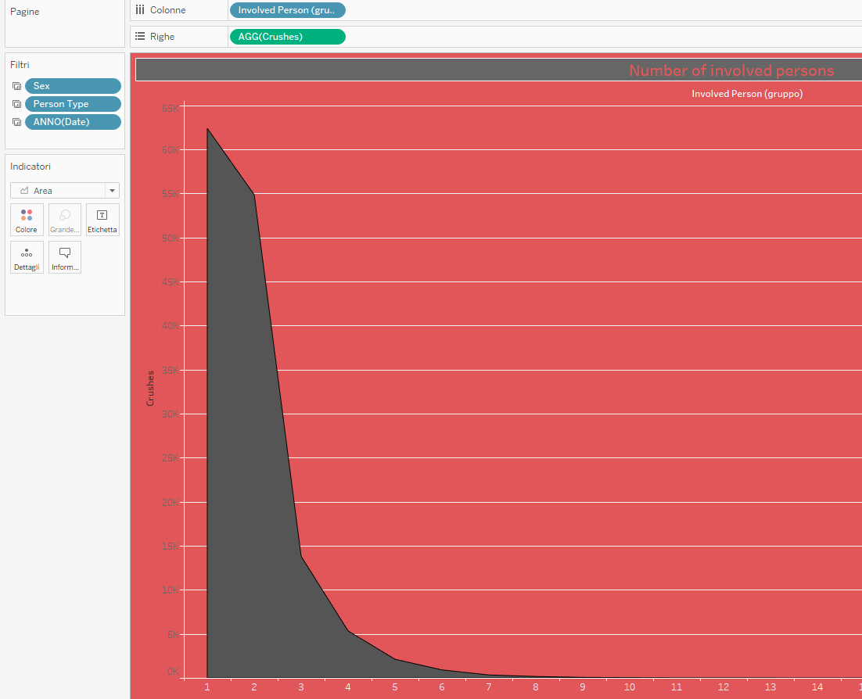

In the sheet Numbers I’ve shown a table that show the number of person per typology of injury.
